**Issue: Getting below error when tried to add Witness DB Server to existing DB Mirroring Setup.**

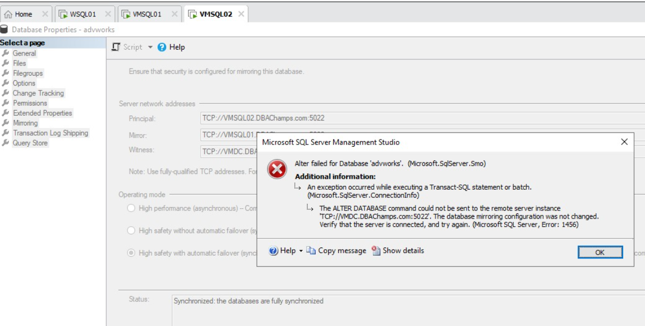

**At Principal DB Server (SQL Server 2019 Dev Edition)**

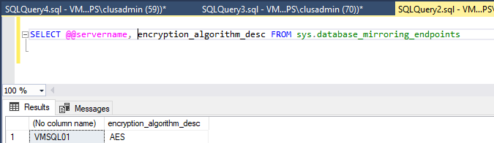

**At Mirror DB Server (SQL Server 2019 Dev Edition)**

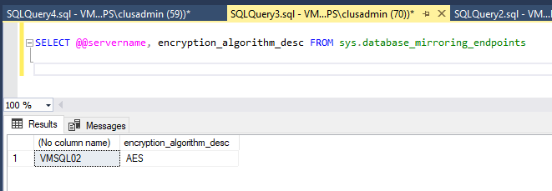

**At Witness DB Server (SQL Server 2016 Dev Edition)**

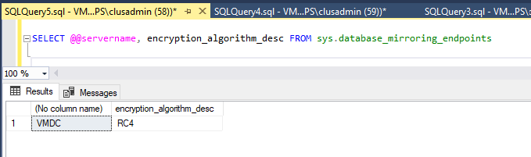

**Cause\Analysis**:

Primary and Secondary Endpoints were using **AES** but the Witness was using **RC4.**

**Fix:**

**On Witness DB Server**:

Dropped the Endpoint on and Re-created it with Encryption Algorithm = AES

(similar to Principal and Mirror Endpoints

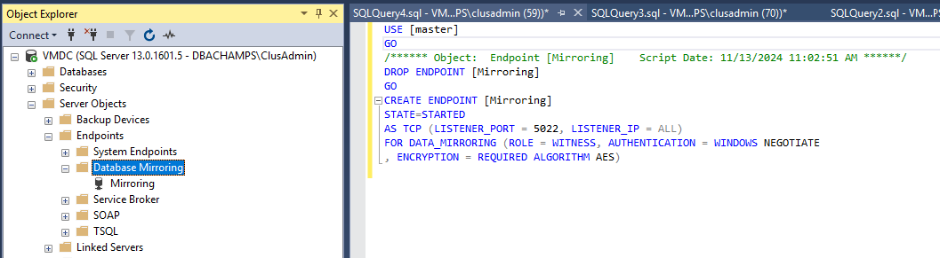

Post above script execution, Witness DB Server was successfully added to existing DB Mirroring.

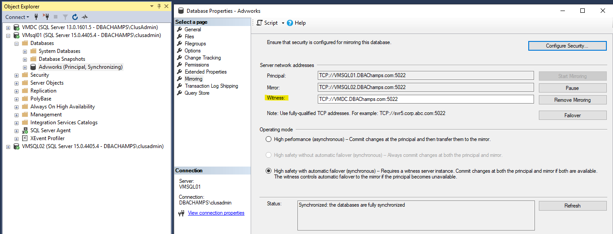

**Reference link used to fix the issue:**

<https://www.reddit.com/r/SQLServer/comments/18mnazq/trouble_adding_a_witness_server_to_a_mirror/?rdt=37536>